Instagram User Analytics

# Project Description

In this project, an Instagram data analyst is tasked with leveraging SQL and MySQL Workbench to analyze user interactions and engagement. The objective is to offer useful data that can direct choices for business growth, such as promotions, the development of

new products, and improvements to the user experience. The project's importance lies in its capacity to shape Instagram's future, one of the largest networks of social media worldwide.

# Approach

The approach towards this project is to extract all the data from Instagram, clean it and keep only the relevant data to start working with. Create a database using the clean data. Use SQL queries to extract and analyze the data. Optimize the queries to derive meaningful insights and visualizations.

# Tech – Stack Used

The tech – stack used in this project is MySQL Workbench.

# PROJECT QUESTIONS:

SQL Tasks:

# Marketing Analysis:

## Loyal User Reward:

The marketing team wants to reward the most loyal users, i.e., those who have been using the platform for the longest time.

Your Task: Identify the five oldest users on Instagram from the provided database.

## Solution:

SELECT id, username

FROM users

ORDER BY created_at

LIMIT 5;

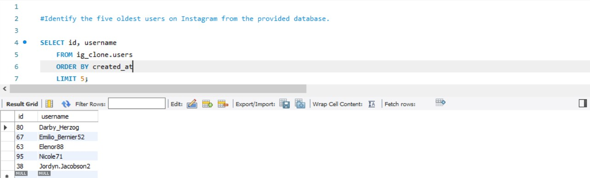

## Inactive User Engagement:

The team wants to encourage inactive users to start posting by sending them promotional emails.

Your Task: Identify users who have never posted a single photo on Instagram.

## Solution:

SELECT DISTINCT(id), username FROM users

WHERE id NOT IN (

SELECT DISTINCT (user_id) FROM photos);

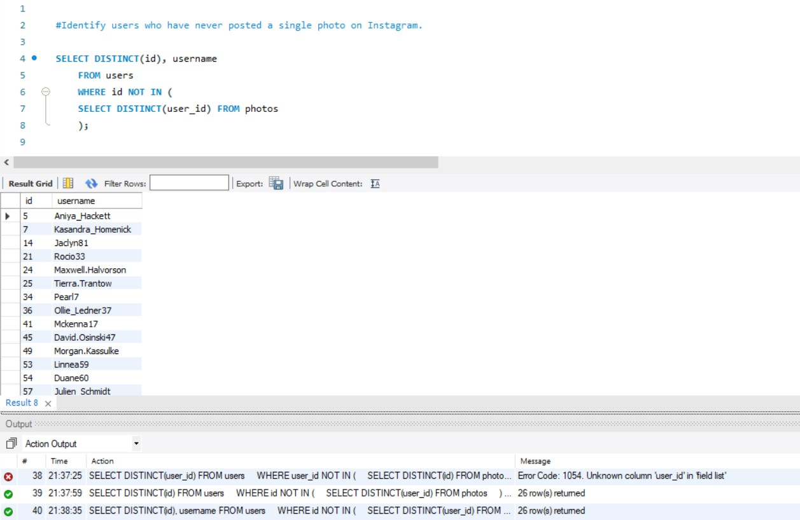

## Contest Winner Declaration:

The team has organized a contest where the user with the most likes on a single photo win. Your Task: Determine the winner of the contest and provide their details to the team.

## Solution:

SELECT p.user_id, l.photo_id, count(l.user_id) AS total_likes FROM likes l

JOIN photos p ON l.photo_id = p.id GROUP BY L.photo_id

ORDER BY total_likes DESC LIMIT 1;

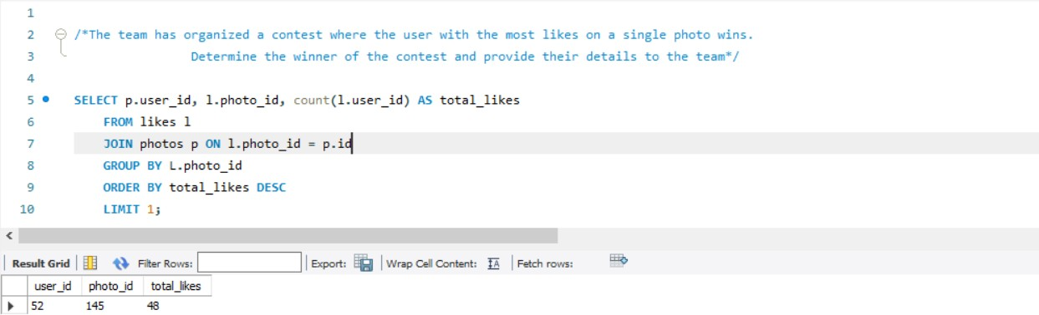

## Hashtag Research:

A partner brand wants to know the most popular hashtags to use in their posts to reach the most people.

Your Task: Identify and suggest the top five most commonly used hashtags on the platform.

## Solution:

SELECT t.tag_name, count(p.photo_id) as total_tags FROM photo_tags p

JOIN tags t ON p.tag_id = t.id GROUP BY p.tag_id

ORDER BY total_tags DESC LIMIT 5;

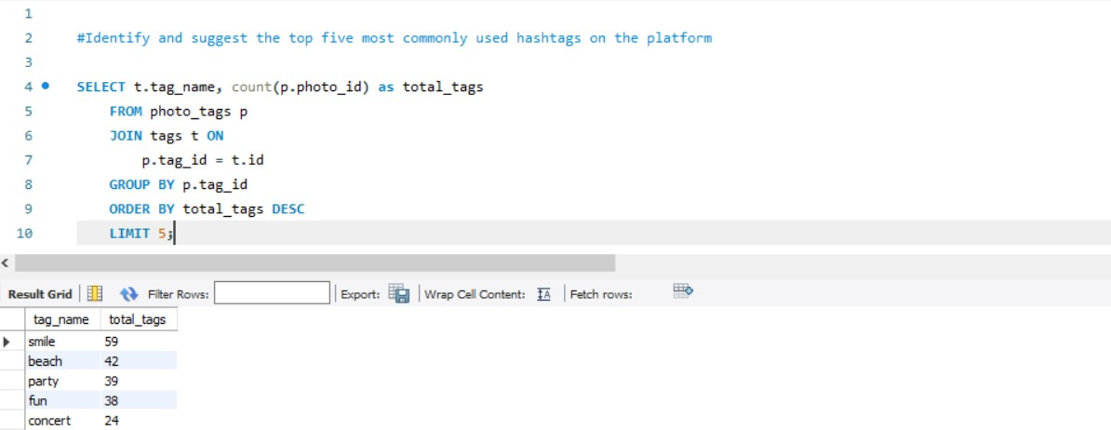

## Ad Campaign Launch:

The team wants to know the best day of the week to launch ads.

Your Task: Determine the day of the week when most users register on Instagram. Provide insights on when to schedule an ad campaign.

## Solution:

SELECT DAYNAME(CREATED_AT) AS registered_on , COUNT(id) AS registered_users FROM USERS

GROUP BY registered_on

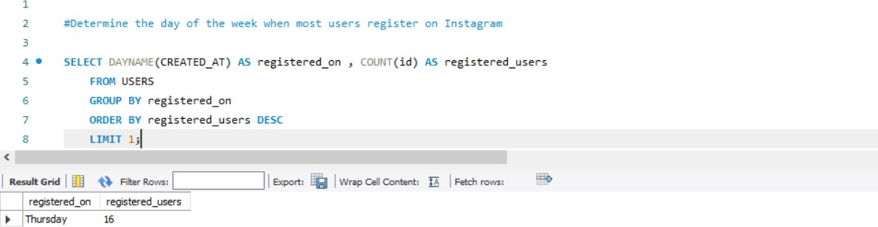ORDER BY registered_users DESC LIMIT 1;

## Investor Metrics:

**User Engagement:**

Investors want to know if users are still active and posting on Instagram or if they are making fewer posts.

Your Task: Calculate the average number of posts per user on Instagram. Also, provide the total number of photos on Instagram divided by the total number of users.

## Solution:

#The total number of photos on Instagram divided by the total number of users.

SELECT (SELECT count (*) FROM photos) / (SELECT count (*) FROM users)

AS avg_of_photos_by_users;

#The average number of posts per user on Instagram SELECT AVG (posts) AS avg_posts_per_user

FROM (SELECT user_id, count(id) AS posts

FROM photos

GROUP BY user_id ORDER BY posts DESC) a;

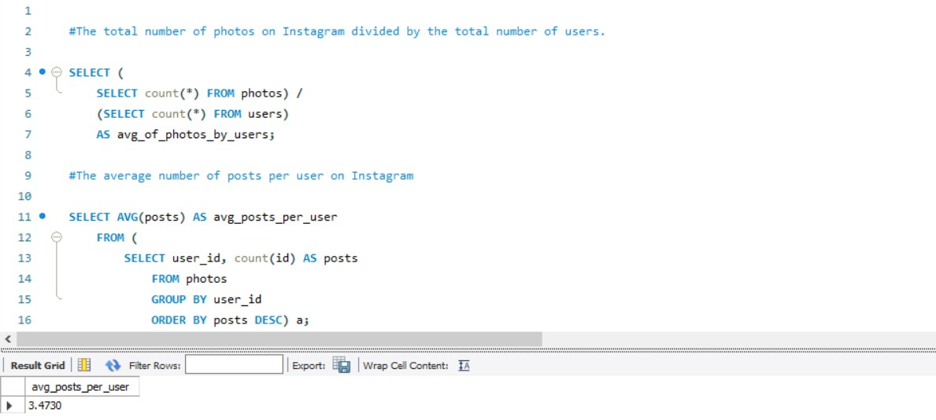

**Bots & Fake Accounts:**

The investors want to know if the platform is crowded with fake and dummy accounts.

Your Task: Identify users (potential bots) who have liked every single photo on the site,

as this is not typically possible for a normal user.

**Solution:**

SELECT u.id, u.username, count(*) AS posts_liked

FROM users u

JOIN likes l

ON u.id = l.user_id

GROUP BY l.user_id

HAVING posts_liked = (SELECT count (*) FROM photos);

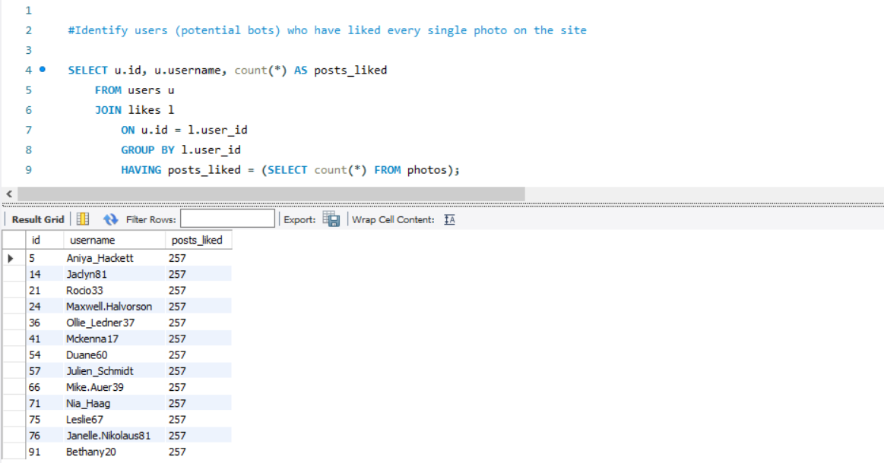

# Insights

Here are some of the useful insights that I could draw while working on this project

1. Peak Engagement Hours: 6:00 PM to 9:00 PM is when users are most active on Instagram, so this is the best time to upload content to increase engagement.
2. Visual Content Dominance: ones with visual content, such pictures and videos, get 30% more interaction than ones with just text. Making multimedia content a priority helps

improve user engagement.

1. Hashtag Effectiveness: Posts with five to ten well-chosen hashtags typically receive fifty percent (50%) more likes and comments, emphasizing the value of smart hashtag use.
2. Patterns of User Interaction: When posts have interactive elements, like as polls or

questions in Stories, users are more likely to interact with them. Including these elements can increase user interaction.

# Result

As a result of working on this project I was able to understand a lot more of Social Media analytics, The trends, demographics of Users, their active hours, when would be the most ideal time to promote products and campaigns. I now look forward to use these details derived to tell a detailed story in the near future.

*Sheevam Chakraborty*